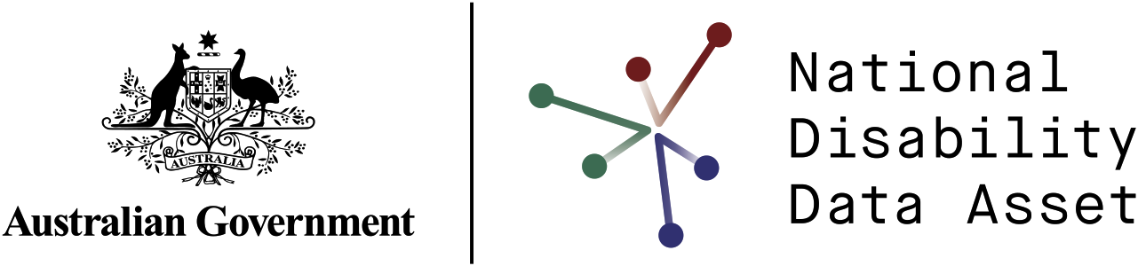

The National Disability Data Asset Factsheet

The National Disability Data Asset will bring together de-identified information from different government agencies about people with disability. This will help us to better understand the experiences of people with disability. The asset will give us more information about programs and services. This will help us to better support people with disability, their carers and the community.



Contents

National Disability Data Asset benefits 3

Benefits for people with disability, their carers and families 3

Benefits for governments 3

Benefits for researchers 3

Types of information in the National Disability Data Asset 4

Keeping information safe 5

Creating the National Disability Data Asset 5

The National Disability Data Asset Pilot 6

We will use the National Disability Data Asset to:

* give a more complete picture of the programs and services people with disability use
* share information about how we can improve opportunities and outcomes for people with disability
* help governments improve supports and services for people with disability
* improve how we report on outcomes for people with disability under [***Australia’s Disability Strategy 2021–2031***](https://www.disabilitygateway.gov.au/ads/glance).

# National Disability Data Asset benefits

## Benefits for people with disability, their carers and families

The disability data asset will improve how people with disability interact with governments and providers. This will help them to be more included in the community.

## Benefits for governments

Governments will use the asset to choose which services and programs to spend money on. It will help them to choose services that provide the best support for people with disability.

## Benefits for researchers

Researchers will be able to use the asset to better understand the life experiences of people with disability. They will be able to share evidence about what works to improve outcomes.

# Types of information in the National Disability Data Asset

The first 3 areas the asset will focus on are:

 **reporting on outcomes under *Australia’s Disability Strategy 2021–2031***

 **health outcomes for people with disability**

 **employment outcomes for people with disability.**

In the future the asset will also include government information on:

 **early childhood development**

 **school education**

 **housing**

 **justice systems**

 **transport.**

# Keeping information safe

Protecting people’s privacy and keeping their information safe is our highest priority.

We will protect access to the asset and how people use the data. We will also de-identify all the data. This means that no one will be able to find out who people are or contact them.

We will protect the asset with rules to make sure the disability community knows how their data is being used and are comfortable with how it is being used.

No one will be able to:

* use the data asset to make decisions about a person’s government funding
* use the data for automatic decision-making tools. This is when a computerised process helps or replaces a human decision-maker.

Representatives from the disability community will make sure the asset is only used for the reasons they have agreed to with the government.

# Creating the National Disability Data Asset

The Department of Social Services is working with the Australian Bureau of Statistics and the Australian Institute of Health and Welfare to create the asset.

States and territories and the disability community are involved in designing and creating the asset. The disability community’s feedback and involvement is important to the success of the project.

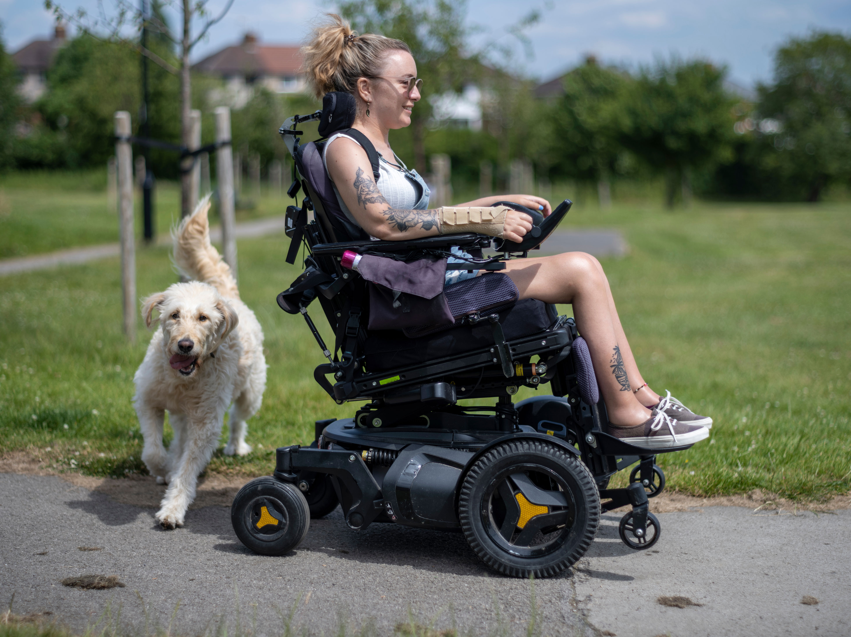

We will continue to work and consult with the disability community and their representatives throughout the project. The disability community will also have a say on the different data products we will create to share information from the asset. For example, we might use the data to create a data dashboard on employment. This would display the different data and track results in a visual and engaging way.

# The National Disability Data Asset Pilot

The disability data asset went through 2 years of development and testing called the Pilot. The Pilot looked at the best ways to share, link and access information.

The Australian, Australian Capital Territory, New South Wales, Victorian, South Australian and Queensland governments worked together on the Pilot.

The Pilot showed new information about people with disability. For example, young adults with disability in South Australia, who worked full time, earned 18% less than those without disability. This kind of information could help governments to improve the pay gap for people with disability.

 



You can read the findings from the Pilot on the National Disability Data Asset website [**www.ndda.gov.au**](http://www.ndda.gov.au/)**.**

You can find more information about the National Disability Data Asset at [**https://ndda.gov.au**](https://ndda.dss.gov.au/) or by emailing [**NDDA@dss.gov.au**](mailto:NDDA%40dss.gov.au).