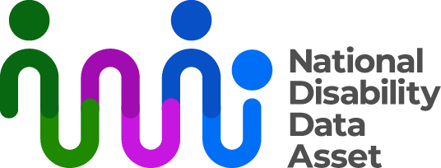

# Measuring disability in the National Disability Data Asset

The National Disability Data Asset brings together information from different government agencies about all Australians. This will help us to better understand and meet the needs of people with disability. All data will be de‑identified so no one can find out who people are or contact them.

Based on early data that will be in the disability data asset, we have designed the first set of disability indicators. We designed the indicators with people with disability, their representatives and experts in disability data.

## Understanding disability indicators

Disability indicators are types of information about disability. For example, how many people have disability and what disability they have. Indicators help us to consistently include and describe people with disability in the disability data asset.

## First disability indicators

The first set of indicators is about disability-related government payments and services.

The indicators include people who:

* took part in the National Disability Insurance Scheme (NDIS)
* were eligible for or received:
  + Centrelink Disability Support Pension
  + Centrelink Mobility Allowance
  + Centrelink Youth Disability Supplement
  + a one-off Business Services Wage Assessment Tool payment
* had carers eligible for Centrelink Carer Allowance or Carer Payment.

This doesn’t represent all people with disability in Australia.

## What the first disability indicators tell us

Looking at the data from 2022, the first set of disability indicators shows that 1.4 million people received disability-related government payments and services during that year. That is 5.4% of the population. Of this group, 812,000 were male and 593,400 were female.

In 2022, the number of people who received disability-related government payments and services included:

* 6.7% of people aged 0 to 14 years
* 6.6% of people aged 15 to 24 years
* 3.6% of people aged 25 to 44 years
* 7.4% of people aged 45 to 64 years
* 3.3% of people aged 65 years and over.

The indicators also show people who received disability-related government payments and services in 2022 included:

* 4.5% of people living in major cities
* 6.7% of people living in either inner or outer regional areas
* 5.2% of people living in remote areas of Australia
* 5.5% of people living in very remote areas.

## Limits and gaps in the current data

We can compare some data from the 2022 Survey of Disability, Ageing and Carers (SDAC) with the data from the first disability indicators. This gives us an idea about how well the indicators include different groups of people with disability.

For example, the SDAC shows there were 5.5 million Australians with disability in 2022. The first indicators include 1.4 million people receiving disability-related government payments and services. This tells us that the data from the first indicators doesn’t cover as many people with disability in Australia.

Many things can affect the data we have about people with disability. For example:

* older people are less likely to be eligible for the payments and services included in the first disability indicators
* people may only be eligible for payments and services at certain times in their life
* some people with disability may not know they are eligible for payments or services
* some people may choose not to share information about their disability.

Groups that the first disability indicators don’t represent well include:

* older people
* people with disability with low or no need for support
* people who pay for private support services.

You can find more information about the limits of the way we identify people with disability at [www.ndda.gov.au/research-projects/insights](http://www.ndda.gov.au/research-projects/insights).

## Improving the future disability indicators

In the future, we want to include more groups of people with disability in the disability data asset. Future releases of the indicators will aim to:

* improve how we measure disability
* better represent more people with disability.

Adding data from states and territories will help achieve these aims. We will also design future indicators with people with disability, their representatives and experts in disability data.

Find more information about the National Disability Data Asset at [ndda.gov.au](https://www.ndda.gov.au/about/) or by emailing [NDDA@dss.gov.au](mailto:NDDA@dss.gov.au).

Sources: Australian Bureau of Statistics Survey of Disability, Ageing and Carers, Australia, 2022; custom Person Level Integrated Data Asset 2022 dataset using approved disability data asset indicators approach.