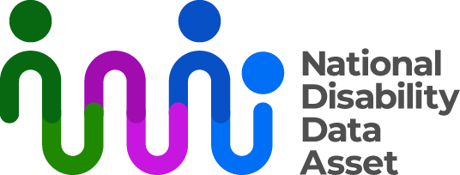

# National Disability Data Asset

# Community Engagement Workshop descriptive transcript

Visual description

On the top right-hand side of an off-white screen there is a black logo with the words National Disability Data Asset. The graphic next to the words is a curved line connected to dots to symbolise linking people and data.

In the middle of the screen an Auslan interpreter dressed in black is signing. The signing is also captioned.

## Audio transcript

Community Engagement Workshop

In July 2024, community members of the National Disability Data Asset Council held a workshop in Sydney to develop an approach to engaging with people with disability and the wider disability community. The aim was to ensure that any engagement is informed by people with disability and the wider disability community.

Members of the National Disability Data Asset Council (Council) - Catherine McAlpine, Dr Scott Avery, Giancarlo de Vera and Commissioner Rosemary Kayess - hosted the workshop and invited guests. The majority of guests were people with disability, and all have strong connections to Disability Representative Organisations and the research community.

* Workshop participants were asked the following questions:
* What do you think your community would like to know about the National Disability Data Asset?
* What do you think your community would like to learn about people with disability from the National Disability Data Asset? (potential research areas)
* How should we tell people about the National Disability Data Asset and when?

Following the workshop, an approach to community engagement for 2024 was approved by the National Disability Data Asset Council.

In the last few months of 2024 and early 2025 the focus will be on building awareness and understanding about the National Disability Data Asset with key representatives of the wider disability community, and also in the disability research community. This includes reviewing, improving, and adding to information available to the public on the National Disability Data Asset website.

The workshop outcomes will also inform the plan for community engagement throughout 2025.

You can learn more information about the Council and their role through the Council’s page on the National Disability Dat Asset website.