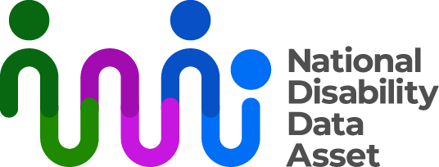

# How the National Disability Data Asset Charter will work

This fact sheet is about how the Council and government will make sure the principles and rules in the National Disability Data Asset Charter (the Charter) are followed. There is a separate fact sheet about the principles and rules in the Charter at <https://www.ndda.gov.au/about-ndda/guiding-principles>.

The Australian government will manage access to and use of the National Disability Data Asset. More information about how researchers can apply to use the National Disability Data Asset is available at https://www.ndda.gov.au/research-projects/apply-data-access. Project requests will go through many checks before researchers are given access to the data. The data is also de-identified which means it does not include any information that can identify a person.

All project requests will be reviewed by people with disability who are part of theDisability-informed Ethical Oversight Panel.

## Step 1: Check applications follow the Charter

Project requests (government and non-government) will be checked to make sure they follow the Charter’s principles and rules. This includes checking that projects commit to put aside money to create accessible versions of their findings. The findings also need to be shared publicly.

## Step 2: Review by the Disability-informed Ethical Oversight Panel

Project requests meet step one will be considered by the Disability-informed Ethical Oversight Panel (the Panel). The Panel is independent from government. Panel members are people with disability and part of the wider disability community. The Panel will check that the research is not likely to cause harm to people with disability. It will provide advice about whether a project should be approved, rejected or updated. Information on approved projects will be published at [www.ndda.gov.au/research-projects](http://www.ndda.gov.au/research-projects.) on the National Disability Data Asset website.

## Step 3: Conditions of access and output checking

Before researchers receive access to data, they must do training on how to use the data responsibly. Researchers will work with the data in a secure IT environment. A secure IT environment is a safe and private virtual location in the cloud. The secure IT environment includes tools to supervise researcher activity. Any misuse that is discovered will be recorded and reported to the appropriate authorities. Before any research data or information is taken out of the secure IT environment, it will be checked by the government. This final check is to make sure the rules of the Charter are followed.

## Reporting to the Council

The Council will receive regular reports on use of the National Disability Data Asset. The reports will list:

* projects which were approved, or not approved
* the number of approved researchers accessing data in the disability data asset
* recommendations from the Disability-informed Ethical Oversight Panel and
* published research findings.

The Council will also be told about any misuse of data, how this was addressed, and what has been done to stop it from happening again.

Information on approved projects and links to accessible research will be published on the [National Disability Data Asset website](http://www.ndda.gov.au).

You can find more information about the National Disability Data Asset at [**www.ndda.gov.au**](http://www.ndda.gov.au/) or by emailing [**NDDA@dss.gov.au**](mailto:NDDA@dss.gov.au)**.**