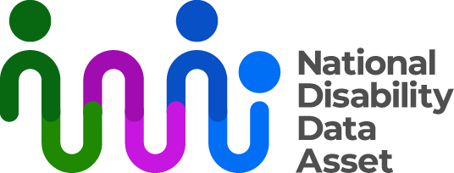

# The National Disability Data Asset Charter descriptive transcript

## Visual description

On the top right-hand side of a dark blue screen there is a logo with the words National Disability Data Asset. The graphic next to the words is a curved colourful line connected to dots to symbolise linking people and data.

On the left of the screen an Auslan interpreter dressed in black is signing.

As each section of the fact sheet begins, the title of the section appears in large words on the screen.

## Audio transcript

### The National Disability Data Asset Charter (The Charter)

The Charter explains how the information in the National Disability Data Asset should be used. It includes some rules and guidelines.

The guidelines make sure that this information includes people with disability and is easy to use and understand. They make sure that this information is used to benefit people with disability. They also make sure information is kept safe.

The rules explain what this information can be used for and what it can’t be used for. Everyone that uses this information must follow these rules.

Any changes need to be checked with the disability community. They also must be approved by the government.

### The rules

To use the National Disability Data Asset, you must have one of these goals for your project. It can teach people about what people with disability need. It can work out how programs improve things for people with disability. It can check if Australia is supporting good accessibility and human rights. It can help people find a service. It can teach people about what families and carers need.

This information must not be used to identify people. It must not affect someone’s payments. It must not break privacy laws. It must not break human rights. It must not be used to punish people. It must not affect government funding without government agreement.

You can find out more at [www.ndda.gov.au](http://www.ndda.gov.au) or by emailing [NDDA@dss.gov.au](mailto:NDDA@dss.gov.au)