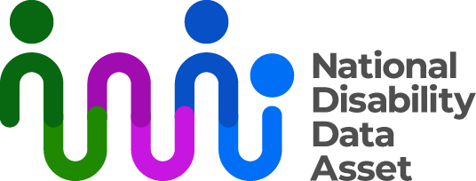

# The National Disability Data Asset Council descriptive transcript

Visual description

On the top right-hand side of a dark blue screen there is a logo with the words National Disability Data Asset. The graphic next to the words is a curved colourful line connected to dots to symbolise linking people and data.

On the left of the screen an Auslan interpreter dressed in black is signing.

As each section of the fact sheet begins, the title of the section appears in large words on the screen.

## Audio transcript

### The National Disability Data Asset Council

The National Disability Data Asset is managed by a Council with twelve members.

### Members

There are three from the Australian Government. There are three from state governments. There are three disability or data experts. There are three disability community members.

Leadership is shared.

### Their work

The Council give advice about how disability information should be used. They also give opinions about how to improve the lives of people with disability.

There is a document explaining what people can do with the National Disability Data Asset. This is called the Charter. There are groups that help guide their work in different areas. These are called Advisory Panels.

The Council will set a goal for how many research projects are developed by people with disability.

The Council will post information about their work online. This information will also be available in Easy Read and Auslan.

You can find out more at [www.ndda.gov.au](http://www.ndda.gov.au) or by emailing [NDDA@dss.gov.au](mailto:NDDA@dss.gov.au)