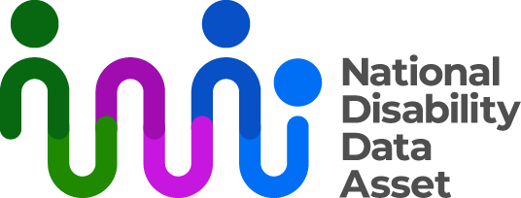

How the National Disability Data Asset Charter will work, descriptive transcript

## Visual description

On the top right-hand side of a dark blue screen there is a logo with the words National Disability Data Asset. The graphic next to the words is a curved colourful line connected to dots to symbolise linking people and data.

On the left of the screen an Auslan interpreter dressed in black is signing.

As each section of the fact sheet begins, the title of the section appears in large words on the screen.

## Audio transcript

### How the National Disability Data Asset Charter (the Charter) will work

The Charter explains rules about how this data can be used. This fact sheet explains how Government will make sure these rules are followed.

### Step 1: Make sure requests for data follow the rules

A government team will check why someone wants to use this data to make sure they don’t break any of the rules.

### Step 2: Review by the Disability-informed Ethical Oversight Panel

Once we are sure the application doesn’t break any rules there will be another check by a special panel. This panel includes people with disability. This panel will make sure that the people using the information will not cause harm to people with disability. They will advise if an application should be approved or rejected.

### Step 3: Conditions of access and output checking

Researchers asking to use this data must do special training first. They will not be given information that includes people’s names or addresses. The research will be done in a secure way.

### Reporting to the Council

There will be regular reports made that will list:

- Approved projects

- Rejected projects

- Published research

- Recommendations from the Oversight Panel

- Any breaking of the rules, how it was managed, and how to stop it happening again.

Information from these reports will also be posted on the NDDA website.

You can find out more at [www.ndda.gov.au](http://www.ndda.gov.au) or by emailing [NDDA@dss.gov.au](mailto:NDDA@dss.gov.au)