# National Disability Data Asset Charter

## How the Charter is used

## Factsheet

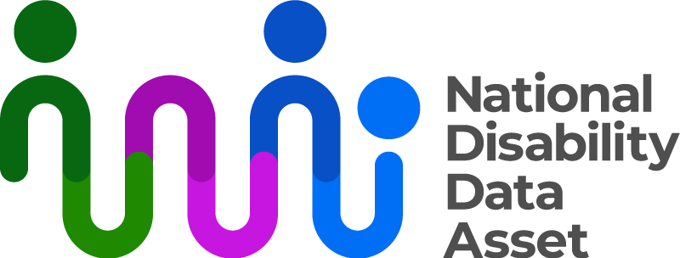

|  |  |
| --- | --- |
| Australian Government logo with Department of Social Services underneath | The Australian Government Department of Social Services wrote this.  We say DSS for short  When you see the word **we** it means the DSS. |
| A person holding a white book with easy read on the cover | We wrote this in an easy to read way.  We use pictures to explain some ideas. |
| The word bold is in bold and the words not bold are in plain text | We have some words in **bold**.  This means the letters are thicker and darker.  These are important words. |
| An easy read document with pictures and lines for text. | This is an Easy Read summary of another document.  This means it has the most important ideas. |
| Two people with their arms around each other with thumbs up. | You can ask for help to read this document.  You can ask   * A friend * Family members * A support person. |
| Aboriginal and Torres Strait Islander fags | We recognise Aboriginal and Torres Strait Islander people as the **Traditional Owners** of the land we live on. |
| teal map of australia | They were the **first people** to live on and use the   * Land * Waters. |

# Contents

|  |  |
| --- | --- |
| About the National Disability  Data Asset | 5 |
| About the National Disability  Data Asset Charter | 7 |
| Research | 9 |
| Reports | 13 |
| Contact us | 14 |

## About the National Disability Data Asset

|  |  |
| --- | --- |
| The National Disability Data Asset logo which is a curved colourful line connected to dots to symbolise linking people and data | The National Disability Data Asset is a new way to connect **data** about people with disability.  We call it the **Data Asset** for short. |
| A graph with a red line | **Data** is   * Facts * Information * Records. |
| A person holding a piece of paper | The data asset will help the **government** make **good decisions** to help people with disability. |
| 9 images of people on the NDDA council | The **National Disability Data Asset Council** make sure the government uses the data asset in a way that helps people with disability.  We call them the **Council** for short. |

About the National Disability Data Asset Charter

|  |  |
| --- | --- |
| a person holding paper that says the charter | The **National Disability Data Asset Charter** helps people understand how to use the data asset.  We call it **the Charter** for short. |
| A group of people with different disabilities posing for a photo | The Charter was made by people in the disability community. |
| a person with thought bubbles that have a thumb up and thumb down | It tells everyone how to use the data asset. |
| 3 people with thumbs up | The Council and the Charter will help people make good decisions about the data asset. |
| a person standing next to a board with lots of green ticks | The Charter makes sure everyone uses the data asset in the right way.  The Charter has   * **Principles** * Rules.   Principles say how the data asset **should work**. |
| a group of people with disability smiling inside a circle with an arrow | **Everyone** has to do what the Charter says. |
| teal computer mouse clicking | You can find more information about the Charter on our website.  [www.ndda.gov.au](http://www.ndda.gov.au) |

Research

|  |  |
| --- | --- |
| 2 people standing either side of a board with a graph | People who want to use the data asset to do **research** need to follow the Charter.  Research means   * Finding out what people think about things. * Using the information to **help others**. |
| A hand holding a pen over an easy read application form | The researchers will write an **application**.  An application is a form you send in asking to use the data asset for your research. |
| book that has ticks and crosses | A team in the government will check the application.  They will make sure the researchers follow the Charter. |
| people looking at paper and sitting around a table | **The Disability informed Ethical Oversight Panel** will look at the applications.  We call them the **Panel** for short.  Panels are groups of people. |
| a person holding a clipbaord with a tick and thumbs up | The Panel makes sure the research is done   * In a good way * Will **not** hurt people with disability. |
| a person with thought bubbles that have a thumb up and thumb down | The Panel will say if they think the research should be done. |
| a person pointing to a pie chart | The Panel will say if the research needs to be changed. |
| 3 people sitting down reading yellow books | Before using the data the researchers need to do **training**.  Training is when you learn how to do something. |
| 3 people with thumbs up | This will help people use the data in a good way.  The researchers will not be given information about anyones   * Name * Address. |
| a person sitting at a table with a computer on it | The researchers will use the data in a  **private way.** |
| a computer with a green tick | That means the data is used   * Safely * Online. |
| a magnifying glass with bar graph inside | The government will check that people have used the data in the right way. |

Reports

|  |  |
| --- | --- |
| an easy read report | To help the Council look after the data asset we will write reports.  The reports will say   * What research used the data. |
| 2 people standing in front of a board with our research on it | * What people found out from their research. |
| a clipbaord with a red cross | * Applications that were **not** allowed to use the data. |
| a person pointing up with a light blub above their head | * **Recommendations** from the Panel.   Recommendations are ideas to do things better. |

## Contact us

|  |  |
| --- | --- |
| teal circle with white i | You can contact us if you **need more information.** |
| teal envelope | You can send us an email.  [NDDA@dss.gov.au](mailto:NDDA@dss.gov.au) |
| teal computer mouse clicking | You can look at our website.  [www.ndda.gov.au](http://www.ndda.gov.au/) |

