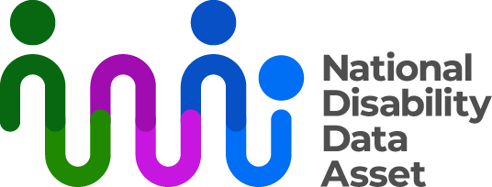

Descriptive transcript

Measuring disability in the National Disability Data Asset

## Visual description

On the top right-hand side of a dark blue screen there is a logo with the words National Disability Data Asset. The graphic next to the words is a curved colourful line connected to dots to symbolise linking people and data.

To the left of the screen an Auslan interpreter dressed in black is signing.

As each section of the fact sheet begins, the title of the section appears in large words on right of the screen.

## Audio transcript

The National Disability Data Asset brings together information from different government agencies about all Australians. All data will be de-identified so no one can find out who people are or contact them. This will help us to better understand and meet the needs of people with disability.

Based on early data, we have designed the first set of disability indicators. We designed the indicators with people with disability, their representatives and experts in disability data. Disability indicators are types of information about disability. For example, how many people have disability and what disability they have.

### First disability indicators

### The first set of indicators are about disability-related government payments and services.

### The indicators tell us information like when people received these payments and services, people’s ages and areas they live in. The first indicators include 1.4 million people receiving these payments and services in 2022.

### This doesn’t represent all people with disability in Australia.

### The indicators include people who:

### took part in the National Disability Insurance Scheme (NDIS)

### were eligible for or received:

### Centrelink Disability Support Pension

### Centrelink Mobility Allowance

### Centrelink Youth Disability Supplement

### a one-off Business Services Wage Assessment Tool payment

### had carers eligible for Centrelink Carer Allowance or Carer Payment.

### Limits of the first disability indicators

### We found that the data from the first indicators doesn’t include some groups of people with disability well. For example:

### older people

### people with disability with low or no need for support

### people who pay for private support services.

### Improving the future disability indicators

### Future releases of the indicators will aim to:

* improve how we measure disability
* better represent more people with disability.

Adding data from states and territories will help achieve this.

Find more information about the disability indicators and the National Disability Data Asset at [ndda.gov.au](https://www.ndda.gov.au/about/).