# National Disability Data Asset Charter

## Factsheet

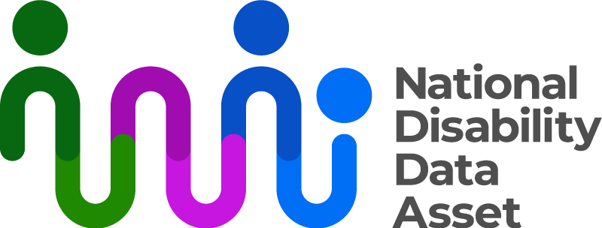

|  |  |
| --- | --- |
| Australian Government logo with Department of Social Services underneath | The Australian Government Department of Social Services wrote this.  We say **DSS** for short.  When you see the word **we** it means the DSS. |
| A person holding a white book with easy read on the cover | We wrote this in an easy to read way.  We use pictures to explain some ideas. |
| The word bold is in bold and the words not bold are in plain text | We have some words in **bold**.  This means the letters are thicker and darker.  These are important words. |
| An easy read document with pictures and lines for text. | This is an Easy Read summary of another document.  This means it has the most important ideas. |
| Two people with their arms around each other with thumbs up. | You can ask for help to read this document.  You can ask   * A friend * Family members * A support person. |
| Aboriginal and Torres Strait Islander fags | We recognise Aboriginal and Torres Strait Islander people as the **Traditional Owners** of the land we live on. |
| teal map of australia | They were the **first people** to live on and use the   * Land * Waters. |

# Contents

|  |  |
| --- | --- |
| About the National Disability  Data Asset | 5 |
| About the National Disability  Data Asset Charter | 7 |
| Principles | 10 |
| Rules | 12 |
| What you cannot do with the  Data Asset | 15 |
| Contact us | 17 |

## About the National Disability Data Asset

|  |  |
| --- | --- |
| The National Disability Data Asset logo which is a curved colourful line connected to dots to symbolise linking people and data | The National Disability Data Asset is a new way to connect **data** about people with disability.  We call it the Data Assetfor short. |
| A graph with a red line | **Data** is   * Facts * Information * Records. |
| A person holding a piece of paper | The data asset will help the **government** make **good decisions** to help people with disability. |
| 9 images of people on the NDDA council | The **National Disability Data Asset Council** make sure the government uses the data asset in a way that helps people with disability.  We call them the **Council** for short. |

About the National Disability Data Asset Charter

|  |  |
| --- | --- |
| a person holding paper that says the charter | The **National Disability Data Asset Charter** helps people understand how to use the data asset.  We call it **the Charter** for short. |
| A group of people with different disabilities posing for a photo | The Charter was made by people in the disability community. |
| a person with thought bubbles that have a thumb up and thumb down | It tells everyone how to use the Data Asset. |
| 3 people with thumbs up | The Council and the Charter will help people make good decisions about the Data Asset. |
| a person standing next to a board with lots of green ticks  a group of people with disability smiling inside a circle with an arrow | The Charter makes sure everyone uses the Data Asset in the right way.  The Charter has   * **Principles** * Rules.   Principles say how the data asset **should work**.  **Everyone** has to do what the Charter says. |
| a person with their hand to their ear | If anyone wants to change the Charter they need to   * Listen to ideas from the disability community |
| a group of people with disability with thumbs up holding a paper | * Have the changes **approved** by the Council and the government.   Approved means they agree to the changes. |

Principles

|  |  |
| --- | --- |
| a person with a clipboard with a green tick on it and thumbs up | The Charter has principles for the Data Asset to be used in a good way.  The **principles** will help people understand how to use it. |
| A group of people with different disabilities posing for a photo | The principles say the data asset will   * Include people with disability. |
| an easy read document | * Have information that is **accessible**.   Accessible means everyone can use it.  Like Easy Read. |
| 2 people shaking hands | * Help people with disability. |
| a person with their finger to their lips | * Keep data safe. |

Rules

|  |  |
| --- | --- |
| a person with their hand on their chin. a bubble above their head as a tick and a cross | The Charter has rules.  The rules tell everyone what   * Can * Cannot   Happen with the data asset. |
| 2 people standing either side of a board with a graph | The data asset **can** be used for **research.**  Research means   * Finding out what people think about things. * Using the information to **help others**. |
| a person with their hands out and a question mark | The data asset can only be used for research that looks at   * How to understand people with disability. |
| a group of people with thumbs up | * Programs to help people with disability. |
| teal map of Australia  A group of people in white t-shirts giving thumbs up | * How Australia helps people with disability speak up about their **rights**.   Rights are rules about treating everyone   * Fair * Equal. |
| a group of people hugging | * Making **inclusive** communities.   Inclusive is when everyone   * Can **take part** * Feel like they **belong**. |
| Person in wheelchair pointing at a screen with two people in formal attire. | * Help people with disability to find services. |
| a group of people with disability smiling inside a circle with an arrow | * Help everyone understand about   + People with disability   + Their families   + Supporters. |

What you cannot do with the data asset

|  |  |
| --- | --- |
| a board with lots of crosses and a person next to it with thumbs down | The Charter has rules about what people **cannot** do with the Data Asset. |
| a person holding their finger to their lips | The data asset **cannot** be used to   * Share **personal information** about people. |
| A brick house with an envelope addressed to it. | Personal information is things like   * Your name * Address * Other information about who you are. |
| a person with thought bubbles that have a thumb up and thumb down | * Decide if a person can get government assistance like   + Centrelink   + NDIS |
| a person holding a clipboard with crosses on it and a sad face | Be used in a way that   * Breaks the law * Does **not** help people speak up about their rights. |
| A person in a floral shirt using a desktop computer with an adaptive keyboard. | Be used by a computer to make sure people follow the rules.  Like the rules to get government assistance. |

## Contact us

|  |  |
| --- | --- |
| teal circle with white i | You can contact us if you **need more information.** |
| teal envelope | You can send us an email.  [NDDA@dss.gov.au](mailto:NDDA@dss.gov.au) |
| teal computer mouse clicking | You can look at our website.  [www.ndda.gov.au](http://www.ndda.gov.au/) |

