# National Disability Data Asset

# Community Engagement Workshop

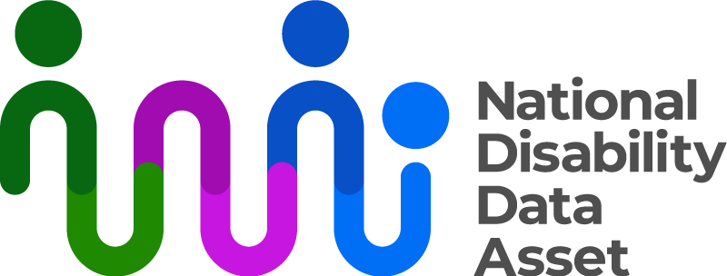

|  |  |
| --- | --- |
| Australian Government logo with Department of Social Services underneath | The Australian Government Department of Social Services wrote this.  We say **DSS** for short.  When you see the word **we** it means DSS. |
| A person holding a white book with easy read on the cover | We wrote this in an easy to read way.  We use pictures to explain some ideas. |
| The word bold is in bold and the words not bold are in plain text | We have some words in **bold**.  This means the letters are thicker and darker.  These are important words. |
| An easy read document with pictures and lines for text. | This is an Easy Read summary about a workshop that was held.  This means it has the most important ideas. |
| Two people with their arms around each other with thumbs up. | You can ask for help to read this document.  You can ask   * A friend * Family members * A support person. |
| Aboriginal and Torres Strait Islander fags | We recognise Aboriginal and Torres Strait Islander peoples as the **Traditional Owners** of the land we live on. |
| Teal map of Australia | They were the **first people** to live on and use the   * Land * Waters. |

# Contents

|  |  |
| --- | --- |
| The National Disability Data  Asset Council | 5 |
| About the workshop | 7 |
| Our plan | 9 |
| Contact us | 11 |

## The National Disability Data Asset Council

|  |  |
| --- | --- |
| The National Disability Data Asset logo which is a curved colourful line connected to dots to symbolise linking people and data | The National Disability Data Asset is a new way to connect **data** about people with disability.  We call it the Data Asset for short. |
| A graph with a red line | **Data** is   * Facts * Information * Records. |
| A person holding a piece of paper | The Data Asset will help the **government** make **good decisions** to help people with disability. |
| National Disability Data Asset Council members images | The National Disability Data Asset Council make sure the government uses the **Data Asset** in a way that helps people with disability  We call them the **Council** for short.  There are 12 people on the Council. |

## About the workshop

|  |  |
| --- | --- |
| A group of people standing around a person in a wheelchair with speech bubbles above their heads. | The Council had a **workshop** in July 2024.  A workshop is when people in a group talk about important   * Ideas * Issues. |
| A group of people posing for a photo | The Council asked people with disability to come to the workshop. |
| A hand holding a pen over a page with the words questions | The Council asked everyone in the workshop **3** **questions**. |
| A person with her hands out | * What do people want to **know** about the Data Asset? |
| A person giving a thumbs up to another person | * What do people want to **learn** about from research using the Data Asset? |
| 2 people sitting and talking | * How should we **tell** people about the Data Asset? |
| a book with the words plan on the front and a picture of people looking at a white page. | We put all the answers together into a **plan**.  The plan says how we will **share information** with the community. |
| A person holding a clipboard with a green check mark on it | The Council **approved** the plan.  This means they said it is good. |

## Our plan

|  |  |
| --- | --- |
| A person holding a clipboard with a pen and check marks | We want to tell everyone about what the Data Asset is.  We want to work with disability community **representatives**.  Representatives speak up for a group of people. |
| 2 people standing either side of a board with a graph | We also want to work with people in the disability **research** community.  Research means   * Finding out what people think about things * Using the information to **help others**. |
| teal computer mouse clicking | We want to **add** more information to our website. |
| A green and white calendar with numbers 2025. | We will use the information from the workshop to help us **plan** for 2025. |

## Contact us

|  |  |
| --- | --- |
| teal circle with white i | You can contact us if you **need more information.** |
| teal envelope | You can send us an email.  [NDDA@dss.gov.au](mailto:NDDA@dss.gov.au) |
| teal computer mouse clicking | You can look at our website.  [www.ndda.gov.au](http://www.ndda.gov.au/) |

