# National Disability Data Asset Council

## Factsheet

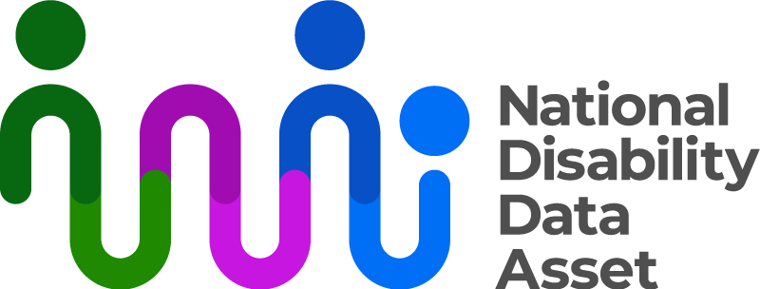

|  |  |
| --- | --- |
| Australian Government logo with Department of Social Services underneath | The Australian Government Department of Social Services wrote this.  We say **DSS** for short.  When you see the word **we** it means the DSS. |
| A person holding a white book with easy read on the cover | We wrote this in an easy to read way.  We use pictures to explain some ideas. |
| The word bold is in bold and the words not bold are in plain text | We have some words in **bold**.  This means the letters are thicker and darker.  These are important words. |
| An easy read document with pictures and lines for text. | This is an Easy Read summary of another document.  This means it has the most important ideas. |
| Two people with their arms around each other with thumbs up. | You can ask for help to read this document.  You can ask   * A friend * Family members * A support person. |
| Aboriginal and Torres Strait Islander fags | We recognise Aboriginal and Torres Strait Islander people as the **Traditional Owners** of the land we live on. |
| teal map of Australia | They were the **first people** to live on and use the   * Land * Waters. |

# Contents

|  |  |
| --- | --- |
| About the National Disability Data Asset | 5 |
| About the Council | 7 |
| What the Council does | 9 |
| About the National Disability Data Asset Charter | 10 |
| Research | 12 |
| Advisory Panels | 13 |
| Reports | 15 |
| Contact us | 17 |

## About the National Disability Data Asset

|  |  |
| --- | --- |
| The National Disability Data Asset logo which is a curved colourful line connected to dots to symbolise linking people and data | The National Disability Data Asset is a new way to connect **data** about people with disability.  We call it the Data Assetfor short. |
| A graph with a red line | **Data** is   * Facts * Information * Records. |
| A person holding a piece of paper | The Data Asset will help the **government** make **good decisions** to help people with disability. |
| 12 people posing for a photo | The **National Disability Data Asset Council** make sure the government uses the Data Asset in a way that helps people with disability.  We call them the **Council** for short. |

About the Council

|  |  |
| --- | --- |
| 9 images of people on the NDDA council | The Council is made up of 12 people. |
| Teal icon of parliament house | 3 people work for the Australian Government. |
| Three people giving thumbs-up, wearing professional attire and ID badges. | 3 people work for state or territory governments. |
| 3 people reading yellow books | 3 people are **experts** in disability.  Experts are people who know a lot about something. |
| 3 people with disability, 1 person in a wheelchair and a person with a guide dog | 3 people from the disability community. |
| 2 people shaking hands | The leaders of the Council are called  co chairs.  They are   * Luke Mansfield * Catherine McAlpine. |
| A person wearng glasses with a beard smiling  a person smiling wearing a green top | Co chairs can be   * A person who works for the Australian Government * A disability community member. |

What the Council does

|  |  |
| --- | --- |
| 3 people leaning over a table looking at a graph | The Council has ideas about the Data Asset. |
| people shaking hands | They tell disability **ministers** how to make the Data Asset better.  Ministers are leaders in an area of the government. |
| a person with their finger pointing up and a lightblub above their head | They also have ideas about how to make things better for people with disability. |

About the National Disability Data Asset Charter

|  |  |
| --- | --- |
| a person holding paper that says the charter | The **National Disability Data Asset Charter** helps people understand how to use the Data Asset.  We call it **the Charter** for short. |
| A group of people with different disabilities posing for a photo | The Charter was made by people in the disability community. |
| a person with thought bubbles that have a thumb up and thumb down | It tells everyone how to use the Data Asset. |
| 3 people with thumbs up | The Council and the Charter will help people make good decisions about the Data Asset. |
| a person standing next to a board with lots of green ticks  a group of people with disability smiling inside a circle with an arrow | The Charter makes sure everyone uses the Data Asset in the right way.  The Charter has   * **Principles** * Rules.   Principles say how the data asset **should work**.  **Everyone** has to do what the Charter says. |

Research

|  |  |
| --- | --- |
| 2 people standing either side of a board with a graph | The Council want people to be able to use the Data Asset to do **research** about people with disability.  Research means   * Finding out what people think about things. * Using the information to **help others**. |
| Man in plaid shirt pointing upward with thought clouds and the word 'Goals'. | The Council have a goal for how much research should be done   * By people with disability * With the disability community |
| Two women talking, one holding a clipboard and pen, both with speech bubbles. | It is important that people with disability are involved in research about themselves. |

Advisory Panels

|  |  |
| --- | --- |
| a group of people sitting around a table with paper on it | The Council have some **Advisory Panels** to help them make decisions.  Advisory Panels are groups of people who know a lot about something.  We call them **Panels** for short. |
| A group of people with different disabilities posing for a photo | Panels are made up of   * People with disability * People who know a lot about disability. |
| A diverse group of five people sitting around a table, engaged in conversation. | In 2024 there were 3 panels.  1. Disability Indicators Panel.  **Disability indicators** are types of information about disability in the Data Asset. |
| 3 people sitting at atable with a board | 2. Disability Data Development Scoping Panel.  This panel looks at what other future panels could do. |
| people looking at paper and sitting around a table | 3. Disability-informed Ethical Oversight Panel.  This panel makes sure the research is done in a good way. |
| a person with thumbs up | Each panel helps the Council in a different way. |

Reports

|  |  |
| --- | --- |
| 2 people shaking hands | The Council want to build trust with the disability community. |
| an easy read document | They do this by putting information about their work on their website.  They put information on their website in   * Easy Read |
| Sign with a white ear symbol on a blue background, crossed by a diagonal bar. | * Videos with **Auslan**.   Auslan is Australian sign language. |
|  | The videos have   * **Captions** * An **interpreter**. |
| Cluster of words with 'Words' in the centre surrounded by 'Stop,' 'Hello,' 'Eat,' 'Open,' 'Day,' and 'Person'. | Captions are the words on the screen of the words being said. |
| Two men standing and talking, one gesturing with his hands. | An interpreter is someone who changes words into other languages.  Like Auslan. |
| teal computer mouse clicking | You can find them on the website.  [www.ndda.gov.au](http://www.ndda.gov.au) |

## Contact us

|  |  |
| --- | --- |
| teal circle with white i | You can contact us if you **need more information.** |
| teal envelope | You can send us an email.  [NDDA@dss.gov.au](mailto:NDDA@dss.gov.au) |
| teal computer mouse clicking | You can look at our website.  [www.ndda.gov.au](http://www.ndda.gov.au/) |

