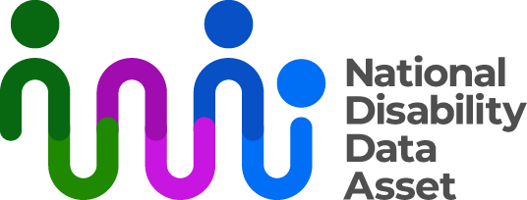

# The National Disability Data Asset Council

The National Disability Data Asset is governed by both people with disability and governments. This is an example of inclusive co-governance. The term inclusive co-governance means that governments and the wider disability community share responsibility and decision making for the National Disability Data Asset.

One way the National Disability Data Asset is inclusively co-governed is through the National Disability Data Asset Council (the Council).

## Council members

The Council has 12 members:

* 6 from the Australian Government
* 3 from state and territory governments
* 3 disability/data experts and
* 3 disability community members.

One disability community member and one Australian Government member are the co-chairs of the Council.

Disability Ministers approved the current Council members in November 2023.

More information about the Council can be found at [www.ndda.gov.au/how-we-work/council](http://www.ndda.gov.au/how-we-work/council%20) on the National Disability Data Asset website.

## The Council’s role and responsibilities

The role of the Council is to make sure the National Disability Data Asset is used appropriately. This means putting into place things that make sure the data is only used for purposes that meet community expectations.

The Council makes recommendations to Disability Ministers about:

* the strategic direction of the National Disability Data Asset, and
* how insights gained from the National Disability Data Asset could be used to improve outcomes for people with disability.

### The National Disability Data Asset Charter

The National Disability Data Asset Charter (the Charter) is a document about how the National Disability Data Asset should be used. It contains principles and rules for the National Disability Data Asset.

The Charter was written by members of the disability community. The Council will guide the use of the National Disability Data Asset through the Charter.

More information about the Charter can be found at [www.ndda.gov.au/about-ndda/guiding-principles](http://www.ndda.gov.au/about-ndda/guiding-principles) on the National Disability Data Asset website.

### Inclusiveresearch

The Charter requires that some research projects are developed by people with disability and the wider disability community. The Council is responsible for setting, monitoring, and reviewing targets on the number of these research projects.

### Building trust, and reporting on progress

The Council aims to build trust in the National Disability Data Asset with people with disability and the wider disability community by publicly reporting on its use and benefits.

The Council meets quarterly and gives:

* public updates on its decisions
* recommendations to Disability Ministers about the National Disability Data Asset.

Council messages from each meeting are published at [www.ndda.gov.au/news-and-updates](http://www.ndda.gov.au/news-and-updates) on the National Disability Data Asset website in Easy Read and Auslan.

The Council will also publish an Annual Report, and a summary of that report will also be available in Easy Read and Auslan.

## Advisory panels

The Council is guided by advisory panels of individuals with experience of and knowledge about disability. These panels will provide regular advice to the Council on priorities for the National Disability Data Asset.

Panel members applied through expression-of-interest processes and were chosen by the Council.

The first 3 panels are the Disability Indicators Panel, the Disability Data Development Scoping Panel, and the Disability-informed Ethical Oversight Panel. Panels provide the Council advice about:

* how to capture the interactions people with disability have with systems and services
* how to improve data in the National Disability Data Asset; and
* the ethics of potential research projects from a disability perspective

More information on the panels can be found at [www.ndda.gov.au/how-we-work/advisory-panels](http://www.ndda.gov.au/how-we-work/advisory-panels) on the National Disability Data Asset website.

You can find more information about the National Disability Data Asset at [**www.ndda.gov.au**](http://www.ndda.gov.au) or by emailing [**NDDA@dss.gov.au**](mailto:NDDA@dss.gov.au).