# Measuring disability in the National Disability Data Asset

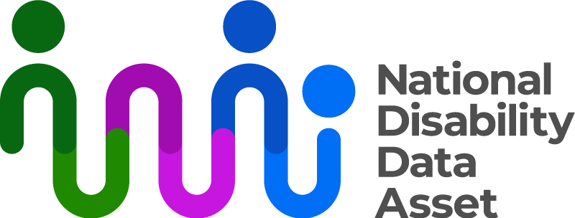

 

|  |  |
| --- | --- |
| Australian Government logo with Department of Social Services underneath | The Australian Government Department of Social Services wrote this.  We say **DSS** for short.  When you see the word **we** it means the DSS. |
| A person holding a white book with easy read on the cover | We wrote this in an easy to read way.  We use pictures to explain some ideas. |
| The word bold is in bold and the words not bold are in plain text | We have some words in **bold**.  This means the letters are thicker and darker.  These are important words. |
| An easy read document with pictures and lines for text. | This is an Easy Read summary of another document.  This means it has the most important ideas. |
| Two people with their arms around each other with thumbs up. | You can ask for help to read this document.  You can ask   * A friend * Family members * A support person. |
| cartoon of Aboriginal and Torres Strait Islander people with the Aboriginal and Torres Strait Islander flags in the background | We recognise Aboriginal and Torres Strait Islander people as the **Traditional Owners** of the land we live on. |
| teal map of australia | They were the **first people** to live on and use the   * Land * Waters. |

# Contents

|  |  |
| --- | --- |
| National Disability Data Asset | 5 |
| First disability indicators | 8 |
| What they tell us | 10 |
| What they did not tell us | 11 |
| How to make them better | 12 |

National Disability Data Asset

|  |  |
| --- | --- |
| The National Disability Data Asset logo which is a curved colourful line connected to dots to symbolise linking people and data | The National Disability Data Asset is a new way to connect **data** about people with disability.    We call it the Data Asset for short. |
| A graph with a red line | **Data** is   * Facts * Information * Records. |
| teal map of australia  Woman in a floral dress making a shushing gesture. | The data asset brings together data about all people in Australia.  We will keep the information safe.  The data will **not** have personal information like names.  No one will   * Know who people are * Be able to contact them. |
| A person holding a piece of paper | The data asset will help the **government** make **good** **decisions** to help people with disability. |
| Graph inside a magnifying glass and a person pointing to it  3 people pointing to paper with an information sign with thumbs up | We looked at the data.  We made the first **disability indicators**.  Disability indicators are types of information about disability in the data asset.  We will call them **indicators** for short. |
| a magnifying glass with lots of groups of people | They can tell us things like   * How many people have a disability |
| a group of people with different disability | * What type of disability they have. |
| a group of people with thumbs up | We made the indicators with help from   * People with disability |
| a person standing in front of a group of workers | * Disability Representative Organisations |
| 2 people looking at a board with data on it | * Data experts. |

## Disability indicators

|  |  |
| --- | --- |
| 2 people looking at a piece of paper | The indicators looked at what help the government gives to people with disability.  Like   * Payments * Services. |
| a group of people with disability | Some payments like   * Disability Support Pension |
| a car driving on the road | * Mobility Allowance |
| a group of teenagers with disability | * Youth Disability Supplement. |
| a carer standing ebhind a person in a wheelchair smiling | We also include people whose carers get payments from Centrelink for |
| a person hugging a person in a wheelchair | * Carer Allowance |
| a person helping a person with a walker | * Carer Payment. |
| fanned out money | People who got a one time Business Services Wage Assessment Tool payment. |
| NDIS logo | Services like   * NDIS. |

## What they tell us

|  |  |
| --- | --- |
| a calendar with a clock on top and a question mark | The indicators tell us  When people got   * Money * Services. |
| a small child, teenager and an older person | How **old** they are. |
| a house with a flag saying your street | The **areas** they live. |

## What they did not tell us

|  |  |
| --- | --- |
| a red cross | The indicators do **not**   * Include all people with disability in Australia * Tell us everything about people with disability. |
| a child a teenager and an older person | The indicators do **not** include some groups of people with disability well.  Like people with disability that are   * Older |
| a person holding a basket  fanned out money | * Do **not** need much support * **Pay** for supports with their own money. |

## How to make them better

|  |  |
| --- | --- |
| a person holding a clipbaord with a tick | We want to make the indicators better.  This means we can get **better** data about people with disability. |
| people leaning over a table with data on a piece of paper | We want to   * Collect more data about disability |
| a mapof Australia with the states and territories different colours | * Do a better job at collecting data.   We do this by adding more data from all the states and territories. |
| teal arrow with lines | You can look at our website for more information.  [www.ndda.gov.au](http://www.ndda.gov.au) |