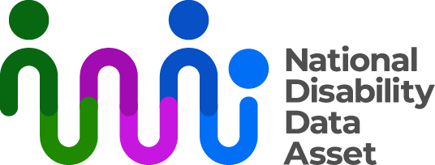

# **Community Engagement Workshop**

In July 2024, community members of the National Disability Data Asset Council held a workshop in Sydney. The plan was to develop an approach to engaging with people with disability and the wider disability community. The aim was to make sure engagement is informed by people with disability and the wider disability community.

Four Council members hosted the workshop, Catherine McAlpine (Co-Chair), Dr Scott Avery, Giancarlo de Vera, and Disability Discrimination Commissioner Rosemary Kayess. They also invited guests to attend the workshop. Most guests were people with disability and all have strong connections to [Disability Representative Organisations](https://www.dss.gov.au/our-responsibilities/disability-and-carers/program-services/consultation-and-advocacy/national-disability-peak-bodies) and the research community.

Workshop participants were asked the following questions:

* What do you think your community would like to know about the National Disability Data Asset?
* What do you think your community would like to learn about people with disability from the National Disability Data Asset? (potential research areas)
* How should we tell people about the National Disability Data Asset and when?

Following the workshop, an approach to community engagement for 2024 was approved by the National Disability Data Asset Council.

The ongoing focus will be on building awareness and understanding about the National Disability Data Asset with:

* key representatives of the wider disability community, and
* the disability research community.

This includes reviewing, improving, and adding to information available to the public on our website.

The workshop outcomes informed the plan for community engagement throughout 2025.

More information about the Council can be found at [www.ndda.gov/au/how-we-work/council](https://oursites/sites/dcg/DCS/NDDA%20%20Key%20Governance%20Documents/NDDA%20Engagement%20Master%20Documents/Stakeholder%20Engagement/NDDA%20Website/Website%20November%202024/www.ndda.gov/au/how-we-work/council) [on the National Disability Data Asset website.](http://www.ndda.gov.au/how-we-work/council)

This information is also available in Easy Read and Auslan.